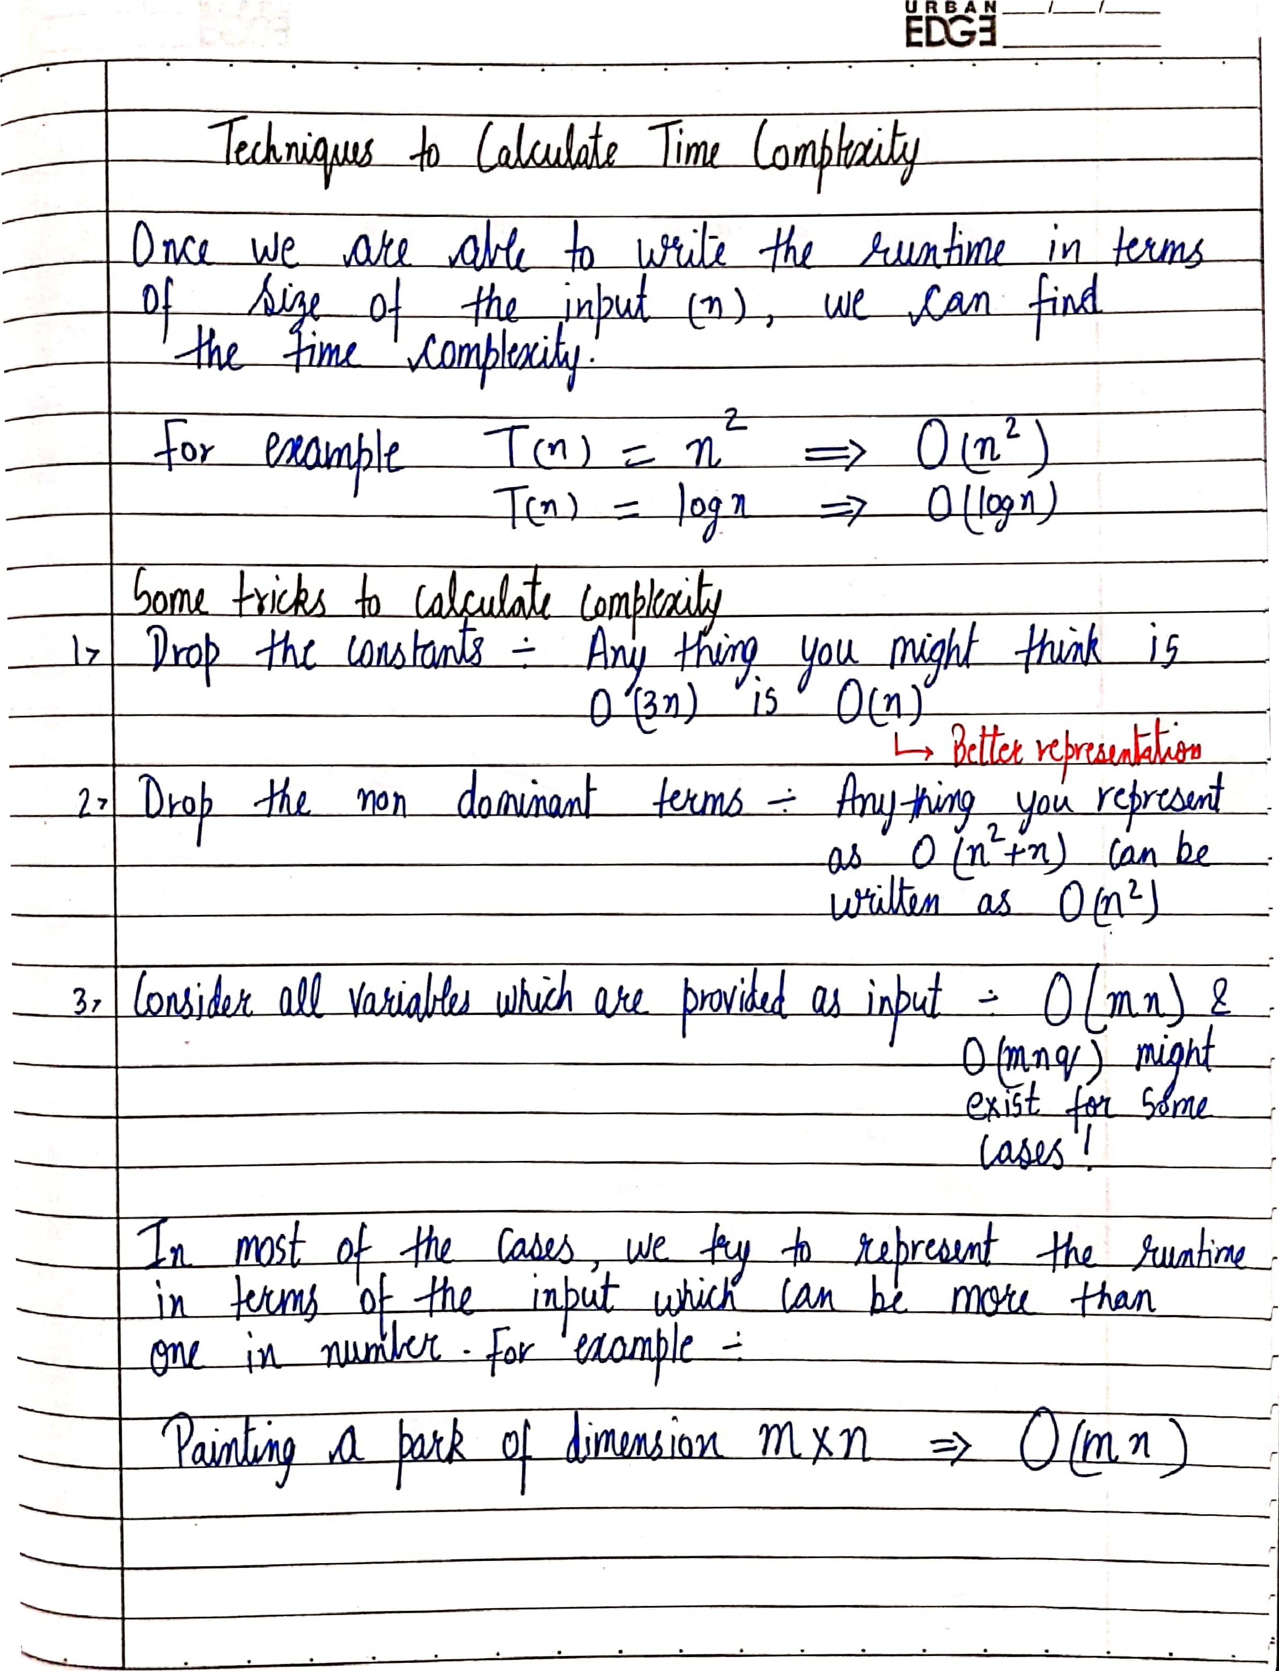
URBAN

Time Complexity – Competitive Practice Sheet

- Fine the time complexity of the func1 function in the program show in program1.c as follows:
#include <stdio.h>

void func1(int array[], int length)
{
int sum = 0;
int product = 1;
for (int i = 0; i < length; i++)
{
sum += array[i];
}

for (int i = 0; i < length; i++)
{
product *= array[i];
}
}

int main()
{
int arr[] = {3, 5, 66};
func1(arr, 3);
return 0;
}

- Fine the time complexity of the func function in the program from program2.c as follows:
void func(int n)
{
int sum = 0;
int product = 1;
for (int i = 0; i < n; i++)
{
for (int j = 0; j < n; j++)
{
printf("%d , %d\n", i, j);
}
}

}

- Consider the recursive algorithm above, where the random(int n) spends one unit of time to return a random integer which is evenly distributed within the range [0,n][0,n]. If the average processing time is T(n), what is the value of T(6)?
int function(int n)
{
int i;

if (n <= 0)
{
return 0;
}
else
{
i = random(n - 1);
printf("this\n");
return function(i) + function(n - 1 - i);
}
}

- Which of the following are equivalent to O(N)? Why?
- O(N + P), where P < N/9
- 0(9N-k)
- O(N + 8log N)
- O(N + M²)

- The following simple code sums the values of all the nodes in a balanced binary search tree. What is its runtime?
int sum(Node node)
{
if (node == NULL)
{
return 0;
}
return sum(node.left) + node.value + sum(node.right);
}
- Find the complexity of the following code which tests whether a give number is prime or not?
int isPrime(int n){
if (n == 1){
return 0;
}

for (int i = 2; i * i < n; i++) {
if (n % i == 0)
return 0;
}

return 1;
}

- What is the time complexity of the following snippet of code?
int isPrime(int n){

for (int i = 2; i * i < 10000; i++) {
if (n % i == 0)
return 0;
}

return 1;
}
isPrime();

